Chapter 5 Sanitary Appliances
The appliances required in building drainage for the eeficient collection and removal of waste water from the building are known as sanitary fixtures and fittings.
The foolwing are the appliances used :
1. Flush toilet (Water Closet)
2. Squat toilet
3. Wash basin
4. Sink
5. Floor trap
6. Urinals
7. Bathtub
8. Shower
9. Bidet
10. Mixing tap
11. Pop up waste
1. Water Closet (Flush Toilet) A flush toilet (also known as a flushing toilet, water closet (WC) is a toilet that disposes of human excreta (urine and feces) by using water to flush it through a drainpipe to another location for disposal, thus maintaining a separation between humans and their excreta. Flush toilets can be designed for sitting (in which case they are also called "Western" toilets) or for squatting, in the case of squat toilets.
Flush toilets are a type of plumbing fixture and usually incorporate an "S", "U", "J", or "P" shaped bend called a trap that causes water to collect in the toilet bowl and act as a seal against noxious gases. Most flush toilets are connected to a sewerage system that conveys waste to a sewage treatment plant; where this is not available, a septic tank may be used. When a toilet is flushed, the wastewater flows into a septic tank, or is conveyed to a treatment plant.
Requirement of good water closet
i) It should be such that night soil do not stick to it so inner side is galzed
ii) It must provide easy flushing
iii) It must be suitable in use with less water
iv) When night soil fall into the trap , its water should not be splashed

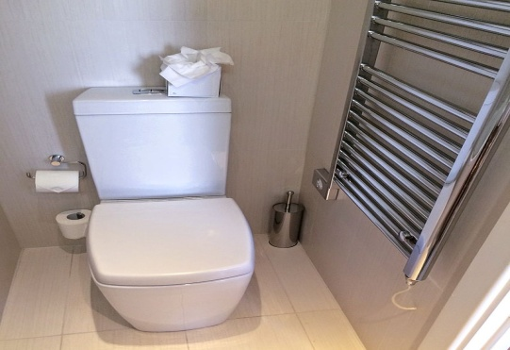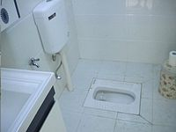
Western Style WC Indian style or Squat Toilet
Western or european style water closet
A water closet provided with a seat and cover is known as waestern or wash down style water closet. It can be provided either high level flusing cistern at 1 m height above ground level or at low level cistern at 0.19 m height.
Advantages of Western toilet
- They are considered more comfortable than Indian toilets since one is simply sitting with hardly any strain on any muscle. Convenient for old age people, patients of osteoarthritis and those undergone recent surgery.
- Some also consider this as modality for social status, while this is not a stronger fact to support it as advantage of western toilets.

Disadvantages of Western Toilets
- There is considerable direct skin contact with the pot, therefore, more chances of Infections.
- There is relative more effort in process of passing stool, as compared to Indian toilets.
2. Indian style or Squat Toilet Indian pots are where one sits with thighs flexed upon abdomen. This is called Squatting Position of passing stool.
Indian toilet or Turkey toilet or the Squat toilet is not actually so called Indian, it has history following from Turkey (Turkey toilet), where it spread to rest of the Asia. Ofcourse most primates sit and do the shit like that, and it has the most significant history over Western Pots.

Advantages of Indian toilet
- Since the person is in squat position, his thighs are flexed over the abdomen. Now, doing this, you are actually increasing the pressure in the abdomen, while simultaneously decreasing the capacity of abdomen. This results in easy expulsion of Stool. Hence, one can say, Squatting position in squat toilets is ideally the best position for passing stool.
- Less chances of Urinary tract infection or UTI, since there is minimal direct contact with the toilet.
Disadvantages of Indian toilets
- Not comfortable for old people, patients of osteoarthritis, and those undergone recent surgeries.
- More severe is the bursting of brain aneurysm which can even lead to death. The person applying pressure can accidentally burst aneurisms in his brain, if any, and those are really fatal to life.
- Blackouts are more common, since Valsalva maneuver leads to increased intra-thoracic pressure and reduced supply to brain.
3. Wsah Basin A washstand or basin stand is a piece of furniture consisting of a small table or cabinet, usually supported on three or four legs, and most commonly made of mahogany, walnut, or rosewood, and made for holding a wash basin and water pitcher. The smaller varieties were used for rose-water ablutions, or for hair-powdering. The larger ones, which possessed receptacles for soap-dishes, were the predecessors of the modern bathroom wash basin, or sink. Both varieties, often of very elegant form, were in extensive use throughout a large part of the 18th century and early-19th century, eventually disappearing with the advent of modern indoor plumbing.
Type of wash basin
i) Pedestal Type
ii) Bracket Type
iii) Flat track
iv) Angel Back

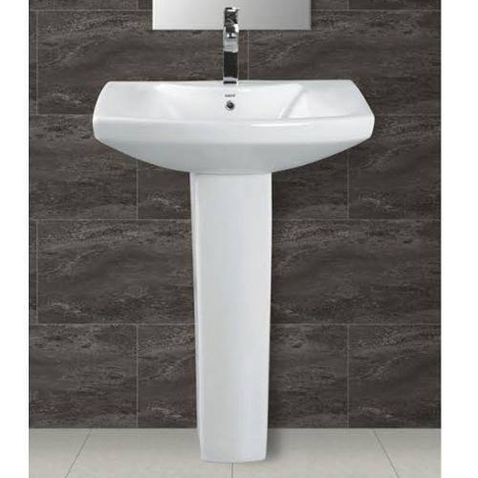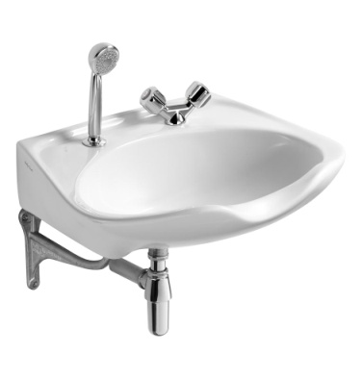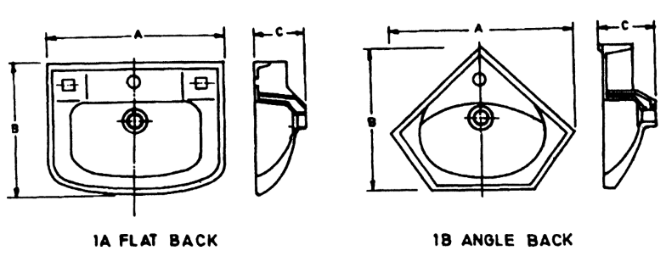
Pedestal Type Bracket type Flat Back

4.0 Sink A sink — also known by other names including sinker, washbowl, hand basin, and wash basin—is a bowl-shaped plumbing fixture used for washing hands, dishwashing, and other purposes. Sinks have taps (faucets) that supply hot and cold water and may include a spray feature to be used for faster rinsing. They also include a drain to remove used water; this drain may itself include a strainer and/or shut-off device and an overflow-prevention device. Sinks may also have an integrated soap dispenser. Many sinks, especially in kitchens, are installed adjacent to or inside a counter.
When a sink becomes clogged, a person will often resort to using a chemical drain cleaner or a plunger, though most professional plumbers will remove the clog with a drain auger (often called a "plumber's snake").

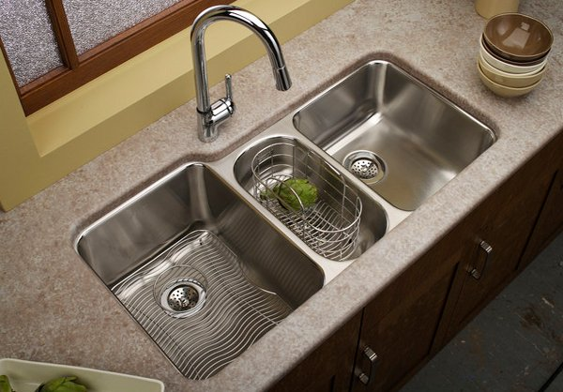
Kitchen Sink
5.0 Floor Trap The trap which are used admitting the surface wash or waste water from the floor of baths or kitchens are called floor trap. It is shown in fig below:
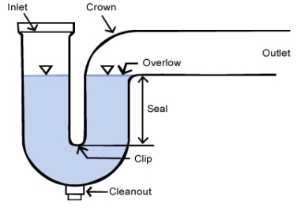

6.0 Urinals The arrangement provided for recieving the human urine is called urinals. Urinals are available in diiferent sizes and shapes and patterns.
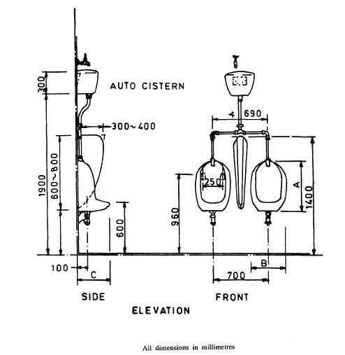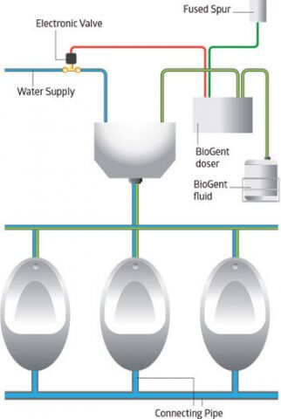
7.0 Bath Tub A bathtub, bath, or tub (informal) is a large or small container for holding water in which a person or animal may bathe. Most modern bathtubs are made of thermoformed acrylic, porcelain enameled steel, fiberglass-reinforced polyester, or porcelain enameled cast iron. A bathtub is usually placed in a bathroom either as a stand-alone fixture or in conjunction with a shower.
Modern bathtubs have overflow and waste drains and may have taps mounted on them. They are usually built-in, but may be free-standing or sometimes sunken. Until recently, most bathtubs were roughly rectangular in shape, but with the advent of acrylic thermoformed baths, more shapes are becoming available. Bathtubs are commonly white in colour, although many other colours can be found. The process for enamelling cast iron bathtubs was invented by the Scottish-born American David Dunbar Buick.
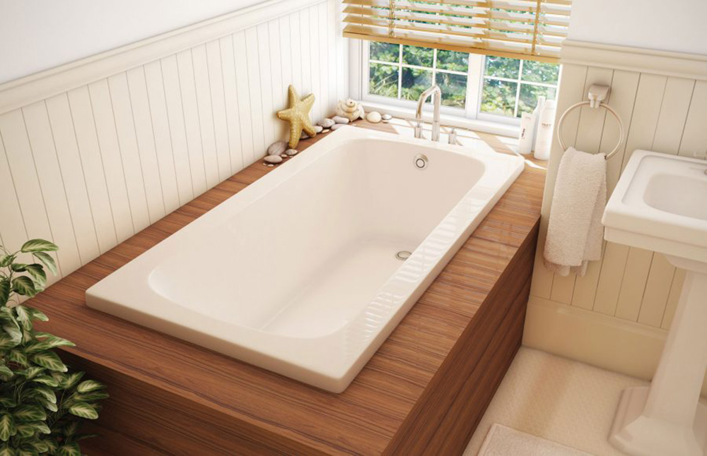
Bath Tub
8.0 Shower A shower is a place in which a person bathes under a spray of typically warm or hot water. Indoors, there is a drain in the floor. Most showers have temperature, spray pressure and adjustable showerhead nozzle. The simplest showers have a swivelling nozzle aiming down on the user, while more complex showers have a showerhead connected to a hose that has a mounting bracket. This allows the showerer to hold the showerhead by hand to spray the water at different parts of their body. A shower can be installed in a small shower stall or bathtub with a plastic shower curtain or door. Showering is common in Western culture due to the efficiency of using it compared with a bathtub. Its use in hygiene is, therefore, common A shower uses less water on average than a bath 80 litres
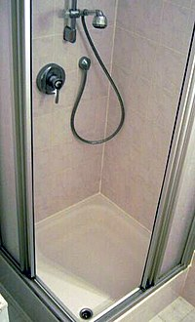
Shower with other fittings
9.0 Bidet It is a bowl or receptacle designed to be sat on for the purpose of washing the human genitalia, perineum, inner buttocks, and anus. The modern variety includes a plumbed- in water supply and a drainage opening, and is thus a type of plumbing fixture subject to local hygiene regulations. The bidet is designed to promote personal hygiene, and is used after defecation, and before and after sexual intercourse, especially by females. In several European countries, a bidet is today required by law to be present in every bathroom containing a toilet bowl. It was originally located in the bedroom, near the chamber-pot and the marital bed, but in modern times is located near the toilet bowl in the bathroom. Fixtures that combine a toilet seat with a washing facility include the electronic bidet.
Opinions as to the necessity of the bidet vary widely over different nationalities and cultures, with the Anglo-Saxon world traditionally shunning it and finding its mere existence a notorious and proverbial source of personal embarrassment and bewilderment. To those world cultures which use it habitually, such as the Islamic world, Sub-Saharan Africa, Southern Europe and the French, it is an essential and indispensable tool in maintaining good personal hygiene. "Bidet" is a French loanword meaning "little horse" due to the straddling position adopted in its usage.
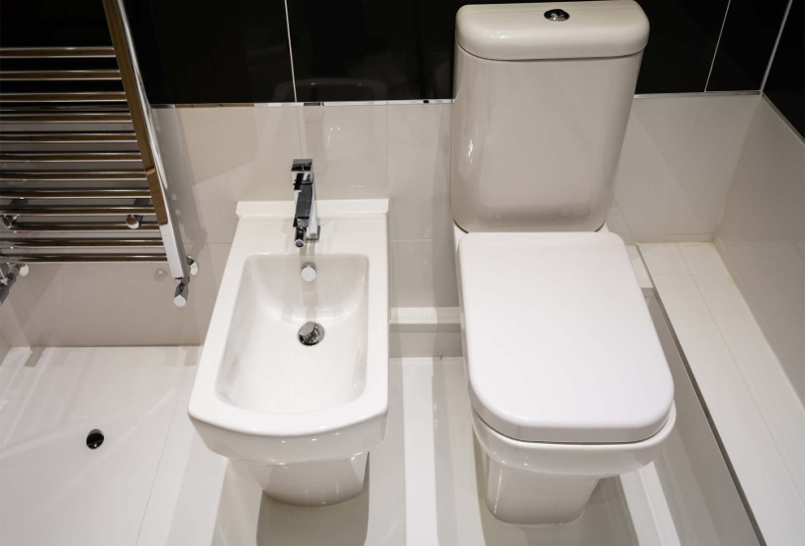
Modern Bidet
10. Mixing Tap When both hot and cold water supply is available , the faucets used on lavatories , bathtubs, bidets and kitchens sinks are to be mixing type. Instead of having two seperate unit (one for hot one for cold water) the mixing tap has the hot and cold water valves combined with a single spigot. This permit adjusting tempertaure of wateras per requirement of the water as per requirement.Hot water connection is given to the left side of the user and cold water is given right side of the used. Hot water is generally identified with red spot on the top of the tap.
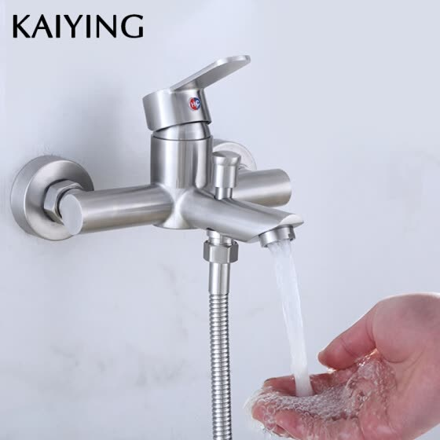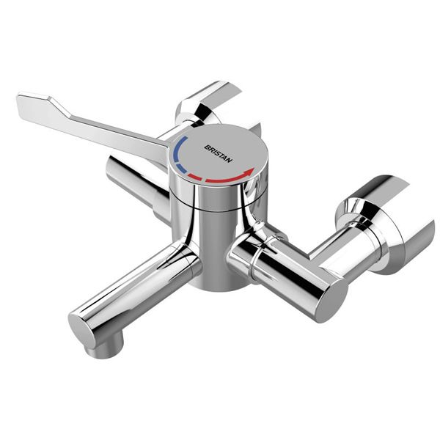
11.0 Pop up Waste It is a pop up assmebly type of pipe fittings that join a sink basin or bidet to waste pipe at the plughole. It incorporate a plug or stoppper which operate by control. It control the popup watse is usaually a lever which is pulled or a knob which is turned.
